January 23rd (Thursday) – 11:30 AM
LOS ANGELES BASIN GEOLOGICAL SOCIETY
LOS ANGELES ASSOC. OF PROFESSIONAL LANDMEN
JOINT MEETING
January 2020
Eric Campbell, President, LA Seismic, LLC
Dan Hollis, CEO, Sisprobe SAS
Robert W. Clayton, Caltech
A Seismic Hazard Survey of the Los Angeles Basin

Abstract

To better understand and model strong earthquake ground motion in the Los Angeles Basin requires better and more accurate knowledge of earthquake sources, basin structure, and basin and near surface velocities. Current knowledge of these three points has been compiled over time from many different sources where there is data and interpolated or extrapolated in areas where data does not exist. A comprehensive and uniform survey that addresses these three points would greatly improve identification of areas of potential high ground motion, provide more detailed after-event shaking data for first responders, and be used to improve the resiliency of critical infrastructure.

We are preparing for such a comprehensive and uniform seismic hazard survey of the Los Angeles Basin. This survey will sample the basin with a nominal density of 10 seismic sensors per square kilometer which will provide sufficient resolution for determining the basin structure and the 3D velocity variations. The survey will consist of about 18,000 receiver positions that will be occupied by a rolling set of 5000 sensors, each occupying a given position for 30 days of passive recording. It will take 4 months for this array to traverse the basin. There will be an additional fixed array of 200 three-component nodes that will record for the entire duration of the survey. The current plan is to supplement the passive seismic data with a limited number of deep shot holes (50m +/-) to obtain 100% or greater CMP-fold reflection data.

Resulting data products for the survey will be Vs and Vp velocity models from surface to Moho, mapping of micro-seismicity events down to about M-1.5, a model of the crust from surface to Moho using receiver functions, and a seismic reflection image of the sedimentary basin using zero-offset autocorrelation and active source seismic CMP methods. This data will be used by researchers to model a variety of earthquake scenarios to develop produce an updated seismic hazard map of the L.A. Basin. Raw data and processed results will be made open source and available to the public.

Speaker’s Biography

Eric Campbell began his seismic mapping career in 1974 in Alaska, working on a summer job as a shooter on a Petty Ray Geophysical Crew on a project in the Aleutian Islands that was staged in Cold Bay Alaska. He worked from 1980 to 1986 with Golden Geophysical (now Fairfield), using the Geo-systems Sine Bit 1024 Channel System. This system enabled the first true 3D seismic surveys to be completed. At that time, Dan Hollis worked at Geosystems and was a participant in aiding these surveys. Eric went on to work in China and again in Alaska for Geosystems. While working in the LA Basin in seismic mapping for the last 10 years, Eric has been the manager of projects that have placed nodes in over 30,000 locations and have vibrated over 15,000 points.

Please join the LABGS to see
Eric and Dan’s presentation!
LABGS Secretary

On behalf of the LABGS Board, I want to express our appreciation to Wanjru Njuguna who served admirably as our secretary these past two years. As she is now the PSAAPG secretary, she could no longer serve as LABGS secretary.

Joseph Landeros, a recent graduate of CSULB, has graciously volunteered to become our new LABGS secretary and Webmaster. Thank you Joseph. His pic appears below so all attendees will be able to introduce themselves to him. Thanks again, Joseph.

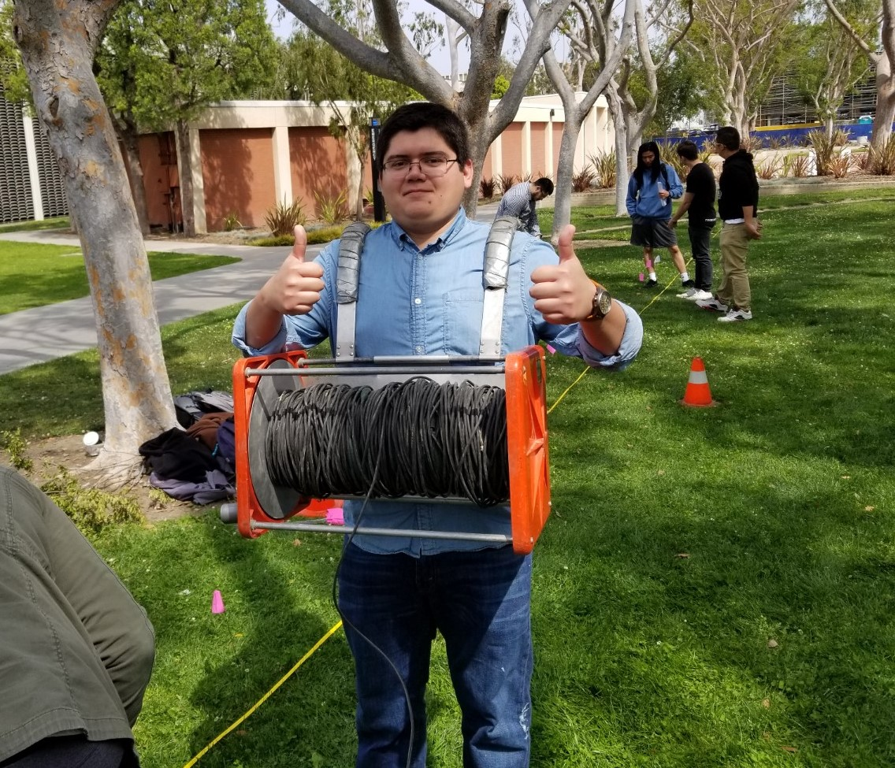

Meeting Time, Place, Cost, and Reservations

When:
Thursday, January 23, 2020

Meeting Agenda

Lunch Served: 11:30 AM to 11:45PM

Announcements: 11:45 AM to 12:00 PM

Guest Speaker: 12:00 PM to 12:45 PM

Questions/Close: 12:45 PM to 1:00 PM

Place:
The Grand at Willow Street Conference Center located at 4101 East Willow Street, Long Beach, CA (562-426-0555). Take Lakewood Boulevard south from the San Diego Freeway (I-405), turn west onto Willow Street, and turn right onto Grand Avenue at the sign for the Center. Park for free in the multi-level garage structure.

Cost:

Lunch and Speaker: $30.00 with reservations
$40.00 without reservations
Retired: $25.00
Student: $10.00
PAYMENTS IN CASH OR CHECK ONLY

Meeting Reservations:
We encourage you to make your reservations using the LABGS web site, at www.labgs.net
Or, call Joseph Landeros at 626-497-1710 or email him at landerosjd@gmail.com
.

Reservations must be made by:
10:00 AM Tuesday January 21
to receive reservations discount price
indicated above
(this will be strictly adhered to)
But, as always, walk-ins are welcome!

OUR WEB SITE ADDRESS:
www.labgs.net
Note change from .org to .net
LABGS Board
Contact Information:

President: Scott Prior
(714) 495-0959
figmo7@gte.net

VP & Programs: Nate Busch
(973) 349-4329
nathaniel.busch@gmail.com
Treasurer: Francine Cason
(562) 756-0270
fcason5@gmail.com

Secretary: Joseph Landeros
(626) 497-1710
landerosjd@gmail.com

Scholarships: Karla Tucker
(714) 658-0474
ktkr2@aol.com

Special Projects: Bill Long
(213) 448-2841
wtlgeoscience@gmail.com

Webmaster: Joseph Landeros
(626) 497-1710
landerosjd@gmail.com

ANNOUNCEMENTS:

The LABGS has expanded our meeting raffles. We would appreciate raffle prize donations! Please bring donation items to the next meeting.

Do you know if your PSAAPG/LABGS membership is current?
If you don’t know, and want to, check via the PSAAPG website:
http://www.psaapg.info/cloud/miscellaneous/dues.php

Please inform a LABGS Board member if you have a pertinent announcement.

